Indicator Evaluation Report

Shrikanth Mahale

[Smahale6@gatech.edu](mailto:Smahale6@gatech.edu)

**Abstract—Indicator illustration and Optimal Strategy for stock trading**

**Question 1: Indicator Illustration**

**Answer:**

The indicators I plan to introduce so far are Simple Moving Average, Bollinger Bands, Momentum, Volatility CCI and Exponential Moving Average (EMA). All of these indicators were calculated for JPM stocks and the prices of the JPM stocks were plotted on all charts for proper comparison.

**Indicator 1: SMA (Simple Moving Average).**

A simple moving average is formed by computing the average price of a stock/security over a specific number of periods. As the name suggest, we calculated a rolling (moving) mean (average) over a specified time window (aka lookback window). For example, a 5-day simple moving average is the five-day sum of closing prices divided by five.

Given below is the mathematical formula.

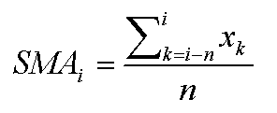

This is helpful because it provides a shot term average which when compared to long term average or average of the entire period, helps us to decide an action to be taken on the stock. So, if a short-term average exceeds a long-term average, it may signal an uptrend.

In this project the SMA was calculated for a moving period of 21 days and plotted as shown in chart next page below. Also, Price/SMA was calculated and plotted.

If we look at the chart below, we observe that the SMA as compared to Price of the stock is more stable. There are moments when the stock price goes above the average and other times when it goes below the average.

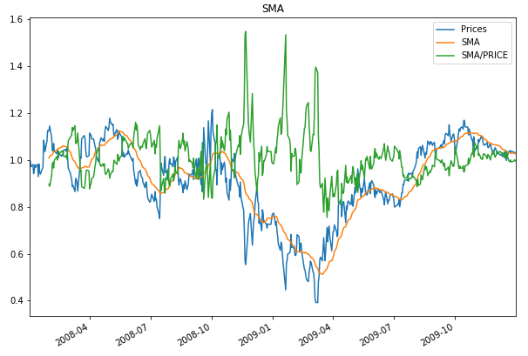

**Indicator 3: Exponential Moving Average**

Exponential moving average is kind of a rolling weighted average in a given time window, unlike simple moving average which gives same weight to all observations in a given time wirdow.

Exponential moving average can be used to identify the direction of the trend or define potential support and resistance levels. An exponential moving average (EMA) is a type of moving average (MA) that places a greater weight and significance on the most recent data points. It is calculated in such a way that it reacts more significantly to recent price changes than a simple moving average.

Given below is the mathematical formula for EMA

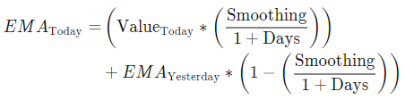

In this project, EMA was calculated or a time window of 21 days and plotted as shown below.

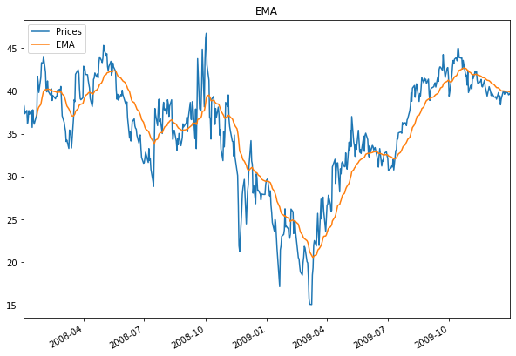

**Indicator 3: Bollinger Bands**

Bollinger Bands® are nothing but volatility bands which are placed above and below a simple moving average. These volatility bands are two standard deviations plotted above (aka upper Bollinger Band) and below SMA (aka upper Bollinger Band). The bands automatically widen when volatility increases and contract when volatility decreases. Increased volatility or wider bands indicates greater possibility of exiting a trade in future and decreased volatility indicates a possibility increasing trade opportunities.

 It is also believed that when a price of a stock moves closer to the upper Bollinger band, the stocks are purchased heavily and when the price is closer to the lower band the stocks are sold heavily.

However, though Bollinger Bands may not be the only indicator to explore volatility, it is definitely a valuable indicator that helps investors in predicting trading opportunities.

Apart from the Bollinger band we also calculated BB Value which indicates relative position of the current price with regards to the bands.

Given below are the mathematical formulas for Bollinger Band and BB Value.

Upper Band = SMA + 2 * (σ Prices )

Lower Band = SMA - 2* (σ Prices )

BB Value = (Prices – SMA)/(2 * σ Prices)

In this project, I have calculated 4 metrics and my graph shows 5 of them and those metrics are SMA, Upper Band, Lower Band, Bollinger Band Value and Price of JPM Stock

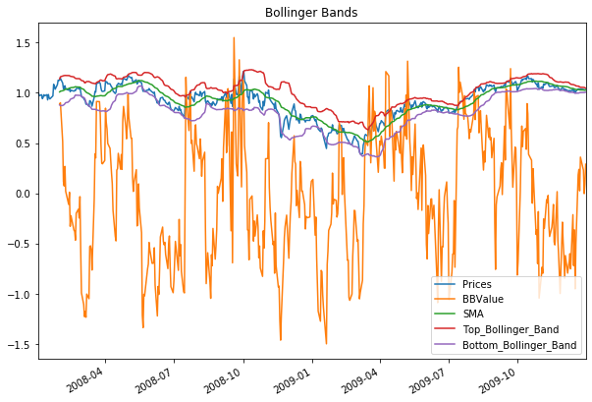

**Indicator 4: Volatility (aka Standard Deviation Volatility)**

Volatility is nothing but variability or dispersion around an average or in other words it is difference between actual value and the average value. Volatility represents certain amount uncertainty or risk associated with the changes in the stock value. It can be said that, higher the volatility, riskier the security of the stock because with high volatility indicates that the price of the stock can be spread out over a large range of value which means that the stock price can change in any direction in short amount of time. Volatility helps a trader identify if a stock is a stable investment or as investment with many ups and down.

The volatility that we have calculated in this project is the rolling standard deviation of daily returns of the stock price.

Daily Returns is a measure of how much a price of a stock goes up or down on a given day.

Given below is the formula for Daily Return

**DR**Today = (**P**Today/**P**Yesterday) – 1

Where DR = Daily Returns and P = Price.

Volatility is further calculated using standard deviation within a rolling window of the Daily return given by mathematical formula below

Volatility = $\sqrt{Daily Returns}$ (over a given window)

In this project Volatility was calculated over a window of 21 days and given below is the graph for volatility

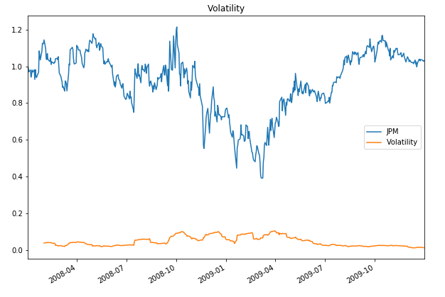

**Indicator 5: CCI (Commodity Channel Index)**

Commodity Channel Index (CCI) is a versatile indicator that can be used to identify a new trend or warn of extreme conditions. In general, CCI measures the current price level relative to an [average](https://school.stockcharts.com/doku.php?id=technical_indicators:moving_averages) price level over a given period of time. CCI is relatively high when prices are far above their average, but is relatively low when prices are far below their average. In this manner, CCI can be used to identify overbought and oversold levels. Positive value of CCI indicates that, prices are well above the average whereas negative CCI indicates that prices are below the average

CCI is calculated using the mathematical formula below

**Commodity Channel Index = (Prices – Rolling Mean)/ (2.5 * σ Prices)**

Where σ Prices is the standard deviation of the prices.

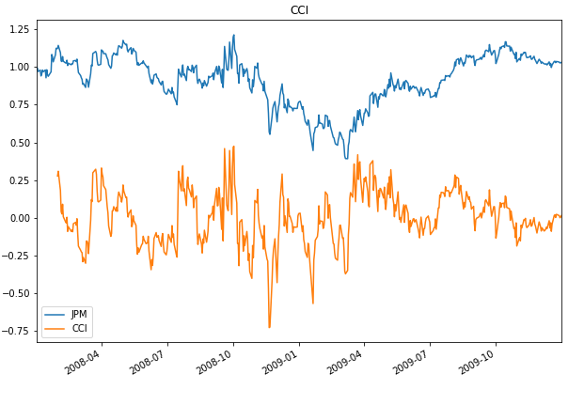

**Question 2: Theoretically Optimal Strategy (TOS)**

**Answer:**

The Theoretically Optimal strategy was built on an assumption that we can peek into the future which is a big assumption. The idea of this strategy was to look at two prices i.e. today’s price and tomorrow’s price and take the ratio of the former with latter and subtract it by 1. This calculated price was called as adjusted price in the code.

Now we were constrained by the portfolio size and order limits where we were only allowed three states i.e. Buy 1000 shares (+1000) or Sell 1000 shares (-1000) or do nothing. (0.00)

So, if the value of the adjusted price is negative then it means that today’s price is lower than tomorrow’s price and we should buy 1000 shares today and sell 1000 shares tomorrow

and if adjusted price is positive then it means today’s price is higher than tomorrow price, so we should sell 1000 shares today and buy 1000 shares tomorrow.

In order to implement this strategy, I first imported prices of JPM stock and adjusted prices were calculated. Based on the adjust price, I perform the transaction or BUY or SELL and store the data into a dataframe. Using that dataframe I calculate portval, cumulative return, average daily return and standard deviation of daily return.

In order to compare Benchmark with TOS, we first defined Benchmark.

Benchmark as the name suggests, is to set a threshold that needs to be attained atleast as a trading strategy. Benchmark in this project is performance of a portfolio starting at $100000 cash and investing 1000 shares of JPM shares and holding that position. At the beginning as demanded in this project, it is normalized at 1.0 at start.

Benchmark was compared with TOS and chart of comparison is shown in next page below. Looking at the chart, we can clearly see that the Theoretically Optimal Strategy we defined outperforms Benchmark by almost 7 times the normalized value of the portfolio.

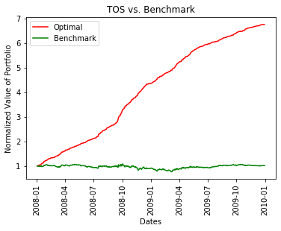

Given below are the performance statistics of Benchmark and TOS stocks.

TOS:

Optimal Cumulative Returns : 5.7624

Optimal Average Daily Returns : 0.003817419250647995

Optimal Standard Deviation : 0.004555095612772053

Benchmark:

Benchmark Cumulative Returns : 0.012299999999999978

Benchmark Average Daily Returns : 0.00016808697819094035

Benchmark Standard Deviation : 0.017004366271213767